CD Warning Chime – CGEA1.3

Functional Description

CD Warning Chime is used to play a chime if the user inserts / ejects a CD from the external CD drive while the vehicle is in motion. The chime will inform the user that this action can be dangerous. An associate text message shall be shown in the center stack HMI, but is out of scope of the IPC STSS.

The configuration of the CD Warning Chime is handled by the Center Stack HMI (e.g. Sync G3 or Connected HMI Radio) hence it is not required in the cluster.

The CD Warning Chime feature correlates the CDWarnChime_St Signal and the operational mode to generate the CD_Warning_Chime_Status_Flag, which will be used by the chime arbitrator.

Interfaces

Interface Context Diagram (I/O Block Diagram)
Figure 1.0 CD Warning Chime Context Diagram

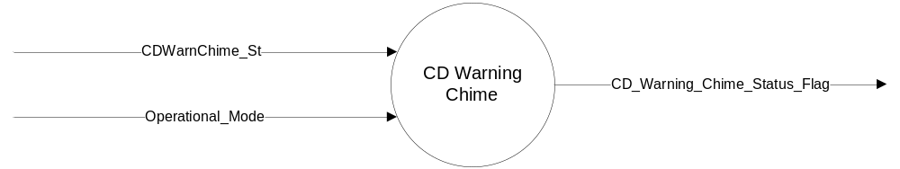

Inputs
- Internal:
  - Operational_Mode
- MUX messages on the CAN Bus

- CDWarnChime_St Signal
Signal Name | Size (bits) | Detail | Units | Res. | Offset | State Encoded | Min | Max
CDWarnChime_St | 1 |  | SED | 1 | 0 |  | 0 (0x0) | 1  (0x1)
CDWarnChime_St |  | Off |  |  |  | 0x0
CDWarnChime_St |  | On |  |  |  | 0x1

Outputs
- Internal flag to Chime Arbitrator – CD_Warning_Chime_Status_Flag.

Function/Performance

Operational Modes

Mode | Differentiating Vehicle Conditions
Sleep Mode | Off
Limited Mode | Off
Normal Mode | Off / On
Crank Mode | Off

Voltage Levels

Refer to Cluster Features Table located in Operational Modes and Voltage Range Strategies section in this SPSS.

Human-Machine Interface

Visual

None

Audio

Refer to Audio Section in Chimes & Chime Arbitrator SPSS Section

Switch Control Logic

Not Applicable.

System Accuracy

- The state of this chime flag shall change within 100 msec of a state change as indicated in the state matrix found in section 1.3.5.1 of this document
- Refer to System Accuracy in Chimes & Chime Arbitrator SPSS Section

Operation: Performance and Functional

Subsystem Algorithm Flowchart / State Diagram

Table 1.1 State Matrix for CD Warning Chime
Operational _Mode | CDWarnChime_St | CD_Warning_Chime_Status_Flag
Normal | On (0x1) | True (0x1)
All other Cases |  | False (0x0)
X = Don’t Care

Operation Description (supports algorithm flowchart /state diagram)

- If the user ejects / inserts a CD to the external CD drive, the CDWarnChime_St CAN signal will be set and held high for the rest of the ignition cycle.
- A text message shall be shown in the centersack HMI and is out of scope for the cluster.
- The CD_Warning_Chime_Status_Flag is set, maintained and cleared by the Center Stack HMI module
- The logic to trigger the chime only once per ignition cycle resides in the centerstack module (Sync G3 / Connected HMI Radio). There is no need to implement such logic in the chime arbitrator / IPC.

Function Safety Classification (EMC)

B

Memory Storage

Parameter Name | Description | Value at Battery connect | Value at  Module Wake-up
CD_Warning_Chime_Status_Flag | State indicator for the chime | FALSE | FALSE
CDWarnChime_St Signal | State indicator for Request input | Off (0x0) | Off (0x0)
Operational_Mode | 4 State indicator for cluster operational mode | Limited | Limited or Normal or Crank
Note: "Do not init" = last known value

Prove Out

No

Reconfigurable Telltale

No

Message Center Msg

No

Error Handling

Missing Message Strategy

None.

Diagnostics

Self Test

None

Engineering Test Mode

While in ETM the chime will behave as the State Matrix, however the chime cannot be triggered through ETM directly. The last chime played is one of the ETM displays. Reference section “Dealer / Engineering Test Mode (ETM)”

Part II Performance

Supported Diagnostic Trouble Codes (DTCs)

None

Reference Specification

None

Revision History

SPSS Module Revision History

Revision Level | Name | Change Description | Date
1.0 | J. Gregoire | Stefan Berg is the feature owner.  Initial release. | 11/10/2015

